**Use Case Summaries Pag-e No**

1. Use Case Diagram 1
2. User Sign-up 2
3. User login Page 3
4. User searches for another user with specific username 4
5. User sends a message to another user 5
6. User receives a message from another user 6
7. User wants to add group description for the group chats 7
8. User wants to delete the chat irrespective of the message is

read/delivered 8

1. User wants to clear all messages from the chat 9
2. User can create group chat 10
3. A Group member can search any other existing group member 11

by the option of group search

1. User would like to invite another user to a group chat. 12
2. User wants to decline invite request 13
3. User can mention(@name) someone in the group. 14
4. Group Admin can add new people in the group 15
5. User wants to be able to remove/delete other specified

members from a group 16

1. Group Admin can view the group members information 17
2. Group Admin can edit/modify the group information 18
3. User wants to exit from the group. 19
4. User can flag some people to make them as preferred. 20
5. User is able to edit/update the user information 21
6. User will be allowed to change their online status at will in

order to let others know how available they are. 22

1. Deleting an account 23
2. User logout from the application. 24

**USE CASE DAIGRAM**

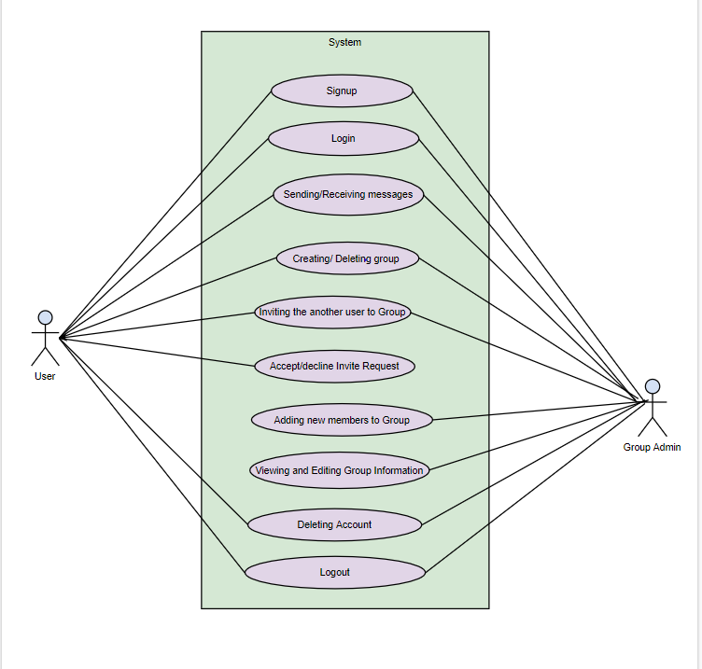

**Use Case 1:**

Name: User Sign-up

Use case summary: A user Sign-up

Actor(s): User

Preconditions:

* User should have a new/unique valid email address.

Description:

Refer to WF2 user enters the email address, name, password to create account in the chat application and click on signup button. The server verifies the given email address is already existing or not. If it exists then, the message is reflected on the page saying that the account has already been created, else the new account is created.

Exceptions:

* When User enters an existing Email Address and clicks on sign up button the pop-up message appears “Account is already created please login”.
* When User enters invalid Name, pop-up message flashes “Please enter valid name” (should not have any special characters and should not exceed maximum word length).
* When User does not enter strong password, pop-up message flashes “Please enter a strong password”

Post conditions:

* An account is created in the database, the user is signed in

**Use Case 2:**

Name: User Login

Use case summary: A User Login

Actor(s): User

Preconditions:

* An account with a known email address is already made.

Description:

Refer to WF1 the user enters the email address and password (both of them are mandatory fields) and press sign in button. The server verifies the credential: email address/password. If the credentials are good the member is signed in and redirected to Home Page (Chat application).

Exceptions:

* The credentials are incorrect. The email field remains the same, but the password field flashes “Incorrect Email/Password, please try again”.

Post Conditions:

* Once signed in the account, user can be able to see WF 6 and the user is redirected to the Conversation page

**Use case 3**

Name: User search

Use case summary: User searches for another user with specific username

Actor(s): User

Preconditions:

* A User must be logged in
* The User should be in the chat room to search [Wireframe #5]

Description:

Refer to WF5 the member enters the specific username. The server verifies and search for that username. If the username is found, it displays the user and related usernames at the search suggestions.

Exceptions:

* If the search is not matching related username then server pops out “No username/results found
* In some cases, it may pop up “Invalid Username” based on the characters entered in the search bar

Post Conditions:

* Once the user is found, click on the suggestion of that particular username or navigating to that username and press “Enter”. The User can now chat with the desired User.

**USE CASE 4**

Name: Send a message

Use case summary: A user sends a message to another user.

Actor(s): User(s)

Preconditions:

* The User is already signed in.
* The user is friends with the other users that they wish to message.

Description:

The user scrolls through their friends list and clicks on a friend in their list that he/she wish to send a message to. After clicking on the friend, the conversation page with that friend will be opened [WF 6]. The user can then type the message they want to send in the message bar in the conversation window and once their message is done, they can either hit the “Enter” button or hit the send button in the window. Once either button is hit the message is sent to the other user.

Exceptions:

* The other user has not acceptedto being friends with the user. In the event this happens a pop up will appear alerting the user of this and their message will be deleted from the servers. The user can then press the OK button to dismiss the pop up.
* The other user has blocked messages from the user. In the event this occurs a pop up will appear on the user’s window stating that they are blocked by the other user and that their message was not sent. The message is deleted. The user can press the OK button to dismiss the pop up.

Post Conditions:

* Once the message is submitted the message will be posted on both users conversation window.

**Use Case 5:**

Name: Receiving a message

Use case summary: A user receives a message

Actor(s): User

Preconditions:

* User must be signed in

Description:

Refer to WF6, User can receive the messages in both individual chat and group conversations. On receiving the messages, the user and the message gets highlighted with a colour.

Exceptions:

* When the other user is not friend with the user then he cannot receive the message.
* When the other user blocks the user then we cannot receive the message.

Post conditions:

* On receiving the message, the user checks/reads them and promptly replies if required.

**Use Case 6:**

Name: Group Description

Use case summary: User should add group description for the group chats.

Actor(s): User

Preconditions:

* Users in the group should be already signed in
* A group should be created at least with minimum of 3 users.
* User can be able to add the participants into the group

**D**escription:

Refer to WF 13, User can see the option of group description on clicking three menu option at the right top of group chat. Once users click on Group description option. It redirects to the other page (WF 14) and can add the group description for the group chats.

Exceptions: None

Post Conditions:

* Once user is redirected to the WF 14, can add the group description.

**Use Case 7:**

Name: Delete a chat

Use case summary: A User wants to delete the chat irrespective of the message is read/delivered

Actor(s): User

Preconditions:

* The User is already signed in.
* The User is in the chat room [Wireframe #7]

Description:

Once the User is logged in and enter in the chat room, he/she can click on the make a select the messages which User wants to delete. By selecting the preferred messages, now we can witness an option of delete and archive message.

Exceptions:

* We cannot undo the deleted messages
* There may be chances of archiving once you select the message since the options of delete and archive, show at one click on the message.

Post Conditions:

* Once the messages have been deleted, it notifies that message has been deleted.

**Use Case 8:**

Name: Clear the chat

Use case summary: Member wants to clear all messages from the chat.

Actor(s): Member(s)

Preconditions:

* Member must be part of the conversation that he/she wishes to delete.
* Member must have the conversation that he/she wishes to delete open.

Description:

The member scrolls through their friends list and clicks on a friend in their list that he/she wish to send a message to. After clicking on the friend, the conversation page with that friend will be opened [WF 6]. Afterwards the member then clicks on the menu button at the top of the conversation window (the three dots button) [WF 8]. Once the menu has appeared the member can then select the clear chat option to delete all messages between the other member and them up till that point.

Exceptions:

* Messages that are favorited or saved will not be deleted. When this occurs, a message will appear stating that some of the messages were not deleted because they were starred or saved. The member can dismiss the pop-up message by clicking the OK button.

Post Conditions:

* Once the clear chat option has been selected all messages will be deleted from the conversation.

**Use Case 9:**

Name: Creating Group Chat

Use case summary: A user can create group chat

Actor(s): User

Preconditions:

* User must be signed in.

Description:

Refer to WF9, User can see the group chat option at the top on clicking the option we have to select users and then the group chat will be created.

Exceptions:

* A Group chat must have at least 3 members in the group if not it is a individual conversation.

Post conditions:

* A group is created, and multiple users can start a conversation.

**Use Case 10:**

Name: Search for a Group Member

Use case summary: A Group member can search any other existing group member by the option of group search

Actor(s): User

Preconditions:

* A User must be group member
* The Member can search the group member when he/she is in the group [Wireframe #10]

Description:

Referring to WF 10, we can clearly inculcate the process of searching the people in group. By clicking the toggle button at the right extreme corner of the group navigation bar, it gives slide down options of group description, search, add people, delete conversation, exit group. Now, a click on the search option takes us to the search bar (group navigation bar) then server suggests he/she can search the preferred member existing in the group by entering the username.

Exceptions:

* If the search is not matching related username then server pops out “No username/results found
* In some cases, it may pop up “Invalid Username” based on the characters entered in the search bar
* If the existing member is same user present in the group then it notifies of user present in chat list and group

Post Conditions:

* Once the user is found, by clicking on user or pressing the button “Enter” then he/she can view the group user profile.

**Use Case 11:**

Name: Group chat invite

Use case summary: User would like to invite another user to a group chat.

Actor(s): User(s)

Preconditions:

* User must be in the group chat.
* User must have permission to invite people to the group.

Description:

The user clicks on the group conversation to bring it up into the conversation window. Once there the user is then able to click on the menu button (three dot button) and select the invite people option. Once selected a window will appear that shows all contacts able to be invited to the group chat. The member is then able to select which contacts he/she wishes to invite and then finished selecting the user is then able to hit the send button in order to send the invites to the selected members.

Exceptions:

* If The user is blocked by the someone that they selected. When this occurs, a pop-up will appear that states that someone was not able to get the invite due to them being blocked. The user can dismiss the message by clicking the OK button.

Post conditions:

* Depending on how many were invited and how many accept the invite the number of people in the group chat will increase.

**Use Case 12:**

Name: Declining invite request

Use case summary: User want to decline invite request

Actor(s): User

Preconditions:

* User is already signed in.
* User is the member of the group.

Description:

Refer to WF11 when user receives the invite request then the message is visible with two options “Accept” or “Decline”. By clicking on the “Decline” user will not be a member of the group.

Exceptions: None

Post conditions:

* After clicking Decline option, now the user cannot able to participate in the group and the user cannot find the group on his chat page.

**Use Case 13:**

Name: Mention user

Use case summary: User can mention(@name) someone in the group.

Actor(s): User

Preconditions:

* Users in the group should be already signed in
* A group should be created at least with minimum of 3 users.
* User can be able to add the participants into the group

**D**escription:

Refer to WF 12, User can mention someone in the group by entering @ at the beginning of the name (user’s name). On sending the mentioned message in the group, it should highlight the color of the name.

Exceptions:

* When user enter space after @ then it doesn’t get notified without any highlighted color.

Post Conditions:

* Once user @ mention someone in the group chat and then click on send button. Message will be delivered in the group

**Use Case 14:**

Name: Add new user in group

Use case summary: A Group Admin can add new people in the group

Actor(s): Admin

Preconditions:

* The user must be group admin
* The Admin will be responsible of inviting or exiting people from group chat [Wireframe #11]

Description:

The option of adding people in the group appears only if he/she is a Group Admin. By clicking the toggle button at the right extreme corner of the group navigation bar, it gives slide down options of group description, search, add people, delete conversation, exit group and click on the Add people option. The system triggers and notifies the recipient if he/she is online.

Exceptions:

* If threshold limit of people in the group is reached, then system triggers and warns the admin with a notification “Maximum limit is reached”
* In some cases, the system doesn’t notify the group admin if he/she denies the request

Post Conditions:

* The User gets an invite request from respected group to accept or deny the request [Wireframe #11]

**USE CASE 15:**

Name: Delete members from group chat

Use case summary: user wants to be able to remove/delete other specified members from a group

chat.

Actor(s): User

Preconditions:

* User must be a part of the group.
* User must have permission to remove people from the group chat.

Description:

The user clicks on the group conversation to bring it up into the conversation window. Once there the user is then able to click on the menu button (three dot button) and select the remove member option. Once selected a pop-up window will appear listing all the members in the group chat. The user is then able to select the members that he/she wishes to remove. Once all are elected the member can then click on the remove button.

Post conditions:

* Once submitted the selected members will be removed from the group chat.

**Use Case 16:**

Name: View the group information

Use case summary: Group Admin can view the group members information

Actor(s): Admin

Preconditions:

* Admin must be a group member

**D**escription:

Refer to WF 13, User can see the option of group info on clicking three menu option at the right top of group chat. It redirects to the other page (WF 14) and can view the contact details of the group description for the group chats.

Exceptions: None.

Post Conditions:

* Once admins click on the group info, it redirects to the information of groups members.

**USE CASE 17:**

Name: Edit group information

Use case summary: A Group Admin can edit/modify the group information

Actor(s): Admin

Preconditions:

* The user must be group admin
* The Admin will be responsible for the information available in the group [Wireframe #14]

Description:

The option of editing information in the group appears only if he/she is a Group Admin. By clicking the toggle button at the right extreme corner of the group navigation bar, it gives slide down options of group description, edit group info (view, edit) etc. Once you click on the edit group info leads us to view group, change group name, change group icon.

Exceptions: None

Post Conditions:

* The User/Admin can now view their desired group name or icon.

**Use Case 18:**

Name: Exit from the group

Use case summary: A user wants to exit from the group.

Actor(s): User

Preconditions:

* User should be signed in.
* User must be member of the group.

Description:

Refer to WF13, on the right corner of the chat page there is 3 dots highlighted when we click on it the dropdown appears. Clicking on exit option the user gets out of the group.

Exceptions: None

Post conditions:

* Now user will not be member of the group.

**Use Case 19:**

Name: Preferred chats

Use case summary: User can flag some people to make them as preferred.

Actor(s): User

Preconditions:

* A user should have an account in the application.

**D**escription:

Refer to WF 17, User can see the flag option at the individual chat window. Once users click on flag option. It takes that chat window to the top of the list as preferred chats. And user can also see the flag icon as the representation of preferred chats.

Exceptions:

* If user do not choose the flag option, it appears as a normal chat window.

Post Conditions:

* Once users click on flag option, it automatically adjusts the preferred chat to the top of conversation lists.

**Use case 20**

Name: Edit user information

Use case summary: A User is able to edit/update the user information

Actor(s): User

Preconditions:

* The user must be logged in

Description:

We can view the default user icon on the right top corner, once you click on the icon at the right top corner, it slides down options of User Info, edit profile, Delete my account and logout [Wireframe #20]. Once you click on the edit group info, it leads us to view group, change group name, change group icon.

Exceptions: None

Post Conditions:

* The User can view those updated changes in user profile.

**Use case 21:**

Name: Availability Status

Use case summary: User will be allowed to change their online status at will in order to let others know how available they are.

Actor(s): User

Preconditions:

* The user must have a verified account.

Description:

A user’s online status will be shown by a dot by their name. A green dot will represent that they are currently active on the site or that they have been within the last 5 minutes. A yellow dot will represent that a user has not been active within five minutes or that they are currently not on the site at all. A user will be able to change their status at will in order to gain some privacy from their contacts if that is their wish. They can do this by clicking on their profile picture and selecting the status option and then click on the status that they wish to portray.

Post conditions:

* User will be able to track the online status of themselves and their contacts in order to determine who is available.

**Use Case 22:**

Name: Delete account

Use case summary: deleting an account

Actor(s): User

Preconditions:

* User should have an account in the application

Description:

Refer to WF25, user can see the user icon on clicking user icon at the right top of chat page. Once user clicks on user icon, it gets deleted.

Exceptions: None

Post conditions:

* User account is deleted from the database
* In the future, when user again tries to create with the same details then it displays as being owned by unknown user

**Use Case 23:**

Name: Logout

Use case summary: User logout from the application.

Actor(s): User

Preconditions:

* A user is already signed in.

**D**escription:

Refer to WF 22, on clicking user icon at the right top, user can see the option of logout.

Once users click on logout, it shows two buttons of logout and cancel. Users can exit from the application on clicking logout button.

Exceptions:

* In some cases, there may be session logout due to shut down while user attempting for logout.

Post Conditions:

* On clicking logout option in user’s account, it redirects to logout page.